Akilan

Table of Contents
1. FAT Allocator without the TLB
1.1. Abstract
1.2. Proposed approach
1.3. Proposed evaluation

FAT Allocator without the TLB

Abstract
This document explores an extension of the FAT allocator approach to memory management in RISC-V Toooba. CHERI introduces a fine-grained memory protection mechanism by embedding bounds and permissions directly within pointers. Leveraging this model, we propose a system in which offsets are stored within the pointer itself, enabling direct memory access without reliance on traditional address translation mechanisms such as the TLB. This method facilitates the design of a block-based memory allocator within physically contiguous memory. The sections expanded below are the technique expected to be used and the evaluation criteria for the following experiment.

Proposed approach
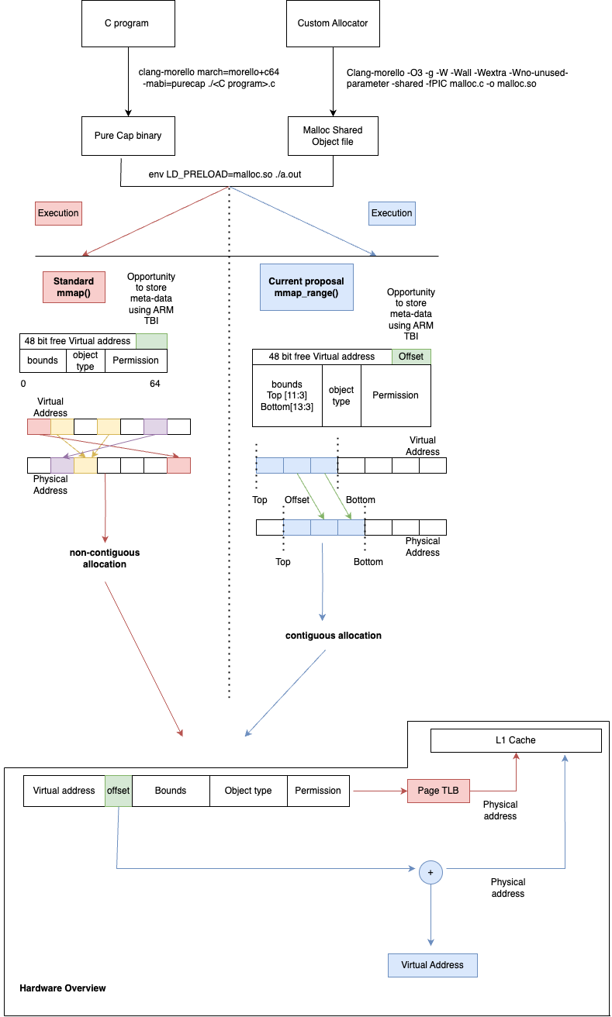 FAT-Pointers based range addresses, combined with the capabilities of the CHERI architecture, introduce bypassing the TLB hierarchy by incorporating additional metadata with memory pointers. This enhanced architecture utilises concepts such as FlexPointer, Range Memory Mapping (RMM) to manage memory as customised sizes rather than groups of fixed page sizes. Range addresses play a pivotal role within this framework, defining memory regions bounded by a starting address (Upper) and an ending address (Lower). These range addresses are encoded within FAT-pointers, allowing for precise control over memory regions. The functionality of ranges encompasses several key aspects:
- Creation of Physically Contiguous Memory Ranges.
- Encoding Ranges as Bounds to the Pointer.
- Instrumenting Block-Based Allocators with the FAT Pointer.
In figure 2.1, the green-highlighted section marks the unused space between the 48th and 64th bits within the FAT-pointer. This area of unused bits presents an opportunity to store additional metadata, potentially enhancing the capabilities of the memory management system. Here we explore how this additional metadata storage could be used to further optimise memory allocation.

Proposed evaluation
\caption{Memory Pipeline Stages}
\begin{algorithmic}[1]

\Procedure{doDispatchMem}{}
\State Enqueue into \texttt{regToExeQ}:
\State \quad \texttt{mem\_func} $\gets x.\texttt{mem\_func}$
\State \quad \texttt{imm} $\gets x.\texttt{imm}$
\State \quad \texttt{tag} $\gets x.\texttt{tag}$
\State \quad \texttt{ldstq\_tag} $\gets x.\texttt{ldstq\_tag}$
\State \quad \texttt{rVal1}, \texttt{rVal2}, \texttt{vaddr}, \texttt{cap\_checks}, \texttt{origBE}, \texttt{shiftBEData}
\State // \texttt{\#ifdef KONATA}
\State \quad \texttt{u\_id} $\gets x.\texttt{u\_id}$
\State // \texttt{\#endif}
\State \quad \texttt{spec\_bits} $\gets \texttt{dispToReg.spec\_bits}$
\EndProcedure

\Procedure{doExeMem}{}
\State \texttt{regToExe} $\gets$ \texttt{regToExeQ.first}
\State \texttt{regToExeQ.deq()}
\State \textbf{if} \texttt{verbose} \textbf{then}
\State \quad Display \texttt{regToExe}
\State \texttt{shiftBE} $\gets$ DataMemAccess(\texttt{x.shiftBEData})
\State \textbf{if} \texttt{x.origBE == TagMemAccess} \textbf{then}
\State \quad \texttt{shiftBE} $\gets$ TagMemAccess
\State \texttt{ddc} $\gets$ cast(\texttt{inIfc.scaprf\_rd(scrAddrDDC)})
\State Compute \texttt{accessByteCount}
\State \textbf{if} \texttt{x.origBE == TagMemAccess} \textbf{then}
\State \quad \texttt{accessByteCount} $\gets$ \texttt{CLineNumMemDataBytes}
\State Call \texttt{procPAddr(x.vaddr)}
\EndProcedure

\Procedure{doFinishMem}{}
\State \texttt{PAddrResp} $\gets$ \texttt{procPAddr.procResp}
\State \texttt{x} $\gets$ \texttt{PAddrResp.inst}
\State \{\texttt{paddr}, \texttt{expCause}, \texttt{allowCapPTE}\} $\gets$ \texttt{PAddrResp.resp}
\State \texttt{cause} $\gets$ Invalid
\State \textbf{if} \texttt{expCause matches Valid c} \textbf{then}
\State \quad \texttt{cause} $\gets$ Valid(Exception(\texttt{c}))
\State \textbf{if} \texttt{verbose} \textbf{then}
\State \quad Display \texttt{procPAddr}
\EndProcedure

\end{algorithmic}

